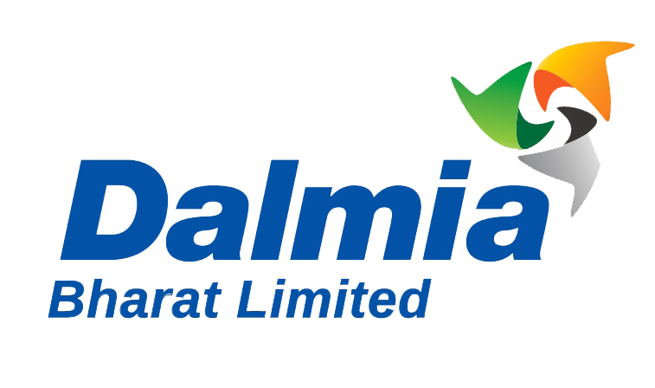
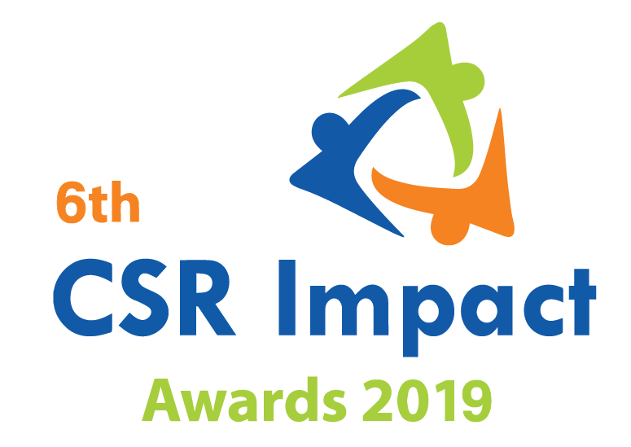
Applying as |  | Project
 | CSR Funding Agency |  | Small
 | CSR Implementing Agency |  | Large

India CSR Summit & Exhibition 2019
6thCSR Impact Awards 2019-Application Form (Category 11)

Please select the Category (Only one category/each form, for more than one category submit separate form and read the guidelines)
1 | Healthcare | ***
2 | Education | ***
3 | Skills Development | ***
4 | Livelihoods | ***
5 | Environment | ***
6 | WASH (Water, Sanitation and Hygiene) | ***
7 | Women Empowerment | ***
8 | Rural Development and Infrastructure | ***
9 | Special Categories (Old Age, Specially-abled and others) | ***
10 | Employee Volunteering Initiative | ***
11 | CSR Project of the Year 2018-19
 | Special Award | ***
12 | CSR Foundation of the Year 2018-19 (only for CSR Foundation) | ***
13 | Company with Best CSR Impacts (2018-19) Only for companies | ***
14 | CSR Implementing Agency of the Year 2018-19 (For implementing agency only) | ***
***Please use the template given on the website for the Category 10, 12, 13 and 14)
(Please read the award-guidelines carefully before submitting this form)
Please send filled in form and application fee to the address below and email a copy to csrimpactawards@gmail.com

NGOBOX (Renalysis Consultants Pvt Ltd)
B-1005, Titanium Heights, Opp. Vodafone House, Corporate Road, Prahalad Nagar,
Ahmedabad 380051 (Gujarat)
Call +91-9560352170, +91-9971429654
Please provide the application fee information here
Application Fee: INR
Paid vide Cheque/DD/NEFT:
Date:
Comment:

Date:
Location:

Part A: Organizational Profile

A1 | Name of the organization applying for the Award (Full Name) (Please do not use acronym)
A2 | Office Address | Address:  Contact No.
A3 | Contact Person for this application (This will be the nodal contact point for this application) | Name:  Designation:  Mobile:  Email:  Alternate Contact no.
A4 | Organization website
A5 | Type of organization | Company  CSR Foundation/Trust  NGO/Section 8/Section 25 company/other
A6 | Name of the CEO/President/Director
A7 | By submitting this application form, the organization agrees to provide all the project related information during the assessment process and will abide by the rules set by the organizers. The applicant also acknowledges that all the information provided in this application form is correct.
 | Seal, Name and Signature of Authorized Representative

Part B: Project Details

B1 | Title of the project
B2 | Project geography (Specify details like state, district, blocks etc)
B3 | Total no. of beneficiaries the project intended to reach
B4 | Total no. of beneficiaries that the project could reach
B5 | Name of the company/companies which has/have given support through CSR funding
B6 | Which are the other partners/institutional engagements in the project? (name of implementing Partners)
B7 | When did the project start and when does it intend to end/ended | Start date:  End date:
B8 | Financial Information | B8.1 | Total Budget of the project/Programme  (INR)
 |  | B8.2 | Project Budget for the Financial Year 2018-19 (INR):  Additional information: % Break-up of the fund spent on:  - Pre-project work  - Project implementation  - Monitoring and evaluation  - Overheads
 |  | B8.3 | Total CSR Budget of the Organization in FY 2018-19(INR)
 | Notes on the financial information (if any):

Part C: Project Summary (Maximum 800 words)

Part D: Project Assessment Questionnaire
(Please provide appropriate facts and relevant information to back your response in each of the point below. Please limit your response to maximum words limit mentioned with each of the point.)

Parameter D1: CSR-Fit and Relevance of the project
- Why was this project planned? What were the main concerns/challenges that this project seeks to address? (200 words)
- Elaborate the general goals and measurable objectives of the project?(200 words)
- Who were the stakeholders of the project, including CSR project implementing partners? Please state primary and secondary stakeholder (if identified)(200 words)
- Who were the project beneficiaries and how were they selected? What was the idea behind selecting these beneficiaries?(250 words)
Parameter D2: Project Design, Innovation and Approach
- What were the highlights of the project implementation? What were the operational processes that the organization adopted to ensure successful implementation of the project?(250 words)
- What strategies did the organization adopt to manage resources and optimize their value?Explain project-spend in terms of number of beneficiaries and average spend on each beneficiary.(300 words)
- How did the project plan to involve each stakeholder in the project? What were the institutional arrangements (involvement of local institutions, government agencies etc.) sought? (200 words)
- Were there any significant roadblocks in the project? If yes, what were those and how did you overcome? (200 words)
- What was innovative about this project (be it process, partnership model, institutional arrangement, adoption technology or novelty of engagement with the stakeholders etc)?(200 words)

Parameter D3: Outcome (Impacts) of the project
- What were the impact indicators (short and long term) of the project? How did the project fare on these indicators?(200 words)
- What were the measures (internal and external) adopted for monitoring and evaluation of the project?(250 words)
- Explain the magnitude of change brought by the project on each stakeholder? Please elaborate quantitative/qualitative changes that the project has made. (500 words)
- Did the project adopt any changes in implementation strategy based on regular monitoring and evaluation of the project performance? If yes, please elaborate. (150 words)
- What was the major learning/s) from the project with regards to implementation and outcomes?(150 words)
- Is there any third party impact evaluation of the project? If yes, please share summary report.

Parameter D4: Scalability of the project
- Elaborate the exit strategy of the project?(250 words)
- What institutional arrangements were done to ensure the sustainability of the outcomes after the completion of the project?(150 words)
- Were there any plans to scale the project in other geographies? Identify the enablers and barriers to scaling up the project?(200 words)
- Why do you think that this project should be considered for the CSR Project of the Year 2018-19? (Max. 1000 words)

Parameter D5: CSR and SDGs
- How does this project help India achieve the SDGs? Elaborate in the context of a specific SDG

Annexure:
- Please add appropriate annexure like tables, images, diagrams, media-reports, web-links). In case you wish to submit a Power point presentation for the project, please send the same along with the application. The maximum number of slides: 10)
- In case you wish to enclose a report or any other documentary proof, please send the same along with the hard copy of the application form and mention the same here.
- If you have third-party evaluation report of the project, please share the same.

__***___

